|  |
| --- |
| **Personal Profile:** |

**Name:** Trin Moungkeaw **Age:** 37 **Date of birth:** March 12, 1985

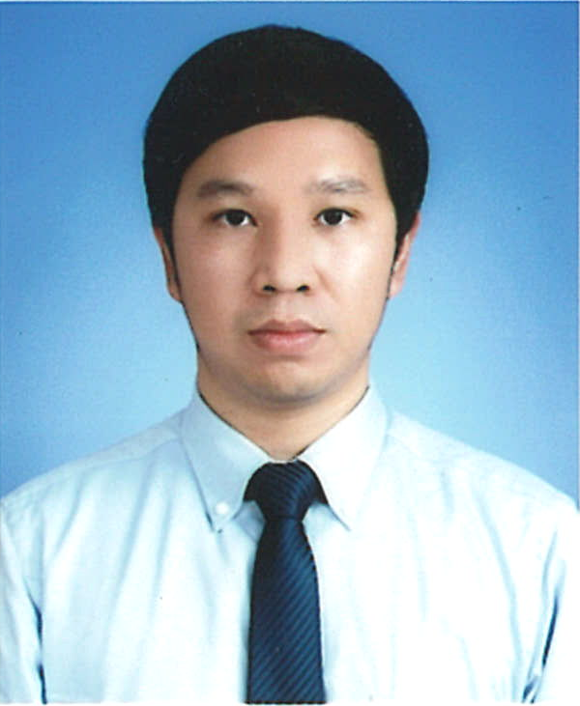

**Nationality:** Thai **Gender:** Male **Marital status:** Single

**Home address:** 109 Moo 5, Laokhwan, Laokhwan, Kanchanaburi, 71210

**Current address:** 99/32,33 Moo 4, Khanham, Uthai, Phra Nakorn Sri Ayutthaya, 13210

**Mobile:** 081-0127505 **E-mail:** gilgamash_1@hotmail.com

|  |
| --- |
| **Educational Profile:** |

**Undergraduate school:** Chiang Mai University May 2004 – Feb 2008

**Faculty:** Engineering **Major:** Computer Engineering **GPA:** 3.26 (Second class honor degree)

**English language skill:**

**Reading:** Good **Writing:** Good **Listening:** Good **Speaking:** Good**TOEIC score:** 945 (September 25, 2020)

|  |
| --- |
| **Professional Profile:** |

**Work experience**

**1. Company:** Nitto Denko Materials (Thailand) Co., Ltd. *[Japanese]* Nov 2020 – Present

**Position:** IT Assistant Manager

**Organization:** Report to Administration General Manager (Thai), work as part of a team (6 person).

**Job summary:** 1. IT policy (create, update, maintain).

2. IT project management (plan, implement, evaluate).

3. Oversee IT system and operation within the company.

4. Client support (650 computers, 1 location).

5. Coach and supervise team member.

6. Budget planning and control.

7. IT procurement (specification, cost effectiveness evaluation, price comparison).

8. Standardize IT internal process.

9. Manage team to achieve target KPIs.

10. Digital transformation and business process improvement.

**2. Company:** Volvo Group (Thailand) Co., Ltd. *[Swedish]* Jun 2019 – Nov 2019

**Position:** Delivery Leader (5 months)

**Organization:** Report to IT General Manager (Thai), work as part of a team (9 person).

**Job summary:** 1. IT policy (update, maintain).

2. Oversee IT system and operation within the company.

3. Client support (300 computers, 1 location).

4. Standardize IT internal process.

5. Manage team to achieve target KPIs.

**3. Company:** Geodis Thai Ltd. *[French]* Feb 2017 – Jun 2019

**Position:** Assistant IT Manager (2 years and 4 months)

**Organization:** Report to IT & Facilities Manager (Thai), work as part of a team (5 person).

**Job summary:** 1. IT policy (create, update, maintain).

2. IT project management (plan, control / implement, evaluate).

3. Manage IT infrastructure (server, network, application, security, database, backup).

4. Web application development (gather requirements, analyze, develop, test, support).

5. Client support (350 computers, 7 locations).

6. Coach and supervise team member.

7. Budget planning and control.

8. IT procurement (specification, cost effectiveness evaluation, price comparison).

**4. Company:** Topre (Thailand) Co., Ltd. *[Japanese]* March 2015 – Feb 2017

**Position:** IT Staff (1 year and 11 months)

**Organization:** Report to IT Manager (Japanese), work alone.

**Job summary:** 1. IT policy (create, update, maintain).

2. IT project management (plan, control / implement, evaluate).

3. Manage IT infrastructure (server, network, application, security, database, backup).

4. Web application development (gather requirements, analyze, develop, test, support).

5. Client support (90 computers, 1 location).

6. Budget planning and control.

7. IT procurement (specification, cost effectiveness evaluation, price comparison).

8. CCTV system.

9. Access control and time attendance system.

**5. Company:** PPC Asian Insulators Co., Ltd. *[Austria]* May 2014 – March 2015

**Position:** IT Officer (10 months)

**Organization:** Report to Financial Controller (Thai), work alone.

**Job summary:** 1. IT policy (maintain).

2. IT project management (plan, control / implement, evaluate).

3. Manage IT infrastructure (server, network, application, security, database, backup).

4. Client support (30 computers, 2 locations).

5. Budget planning and control.

6. IT procurement (specification, cost effectiveness evaluation, price comparison).

**6. Company:** Siam Aisin Co., Ltd. *[Japanese]* May 2008 – Dec 2012

**Position:** Computer Engineer (Senior) (4 years and 8 months)

**Organization:** Report to IT Manager (Thai), work as part of a team (5 person).

**Job summary:** 1. IT policy (create, update, maintain).

2. IT project management (plan, control / implement, evaluate).

3. Manage IT infrastructure (server, network, security, backup).

4. Client support (400 computers, 1 location)

**Personal skills**

Responsibility, Organization, Fast learning, Creativity, Communication

**Management skills**

Problem solving, Critical thinking, Planning, Negotiation

**Technical skills**

**- Server:** Proficient with Windows Server 2003, Windows Server 2008, Windows Server 2008 R2,

Windows Server 2012 R2, Windows Server 2016, AD, DNS, DHCP, GPO, WSUS,

Exchange Server 2003, Exchange Server 2007, Internet Information Services,

File Sharing, Performance Tuning, Server Hardening, Resource Monitoring

Familiar with Linux

**- Client:** Proficient with Windows XP, Windows 7, Windows 8.1, Windows 10, iOS

Familiar with Windows 11, Linux, Mac OS, Android

**- Network:** Proficient with Router (maintain), Switch, Access point (config, manage, maintain),

Network planning, LAN, WLAN, WAN, SD-WAN

Familiar with Router (config)

**- Backup:** Proficient with CA ARCserve, Symantec Backup Exec, Tape Drive, Tape Library, Disk Library

Familiar with HP Data Protector, Veeam

**- Storage:** Proficient with DAS, NAS

Familiar with SAN

**- Security:** Proficient with Firewall (Juniper, FortiGate, Cisco, Sophos), E-mail Gateway (IronPort,

ProofPoint), Web Filtering (Content Keeper, FortiGate, Cisco, Sophos, Squid), Log Keeper

(LogLogic, FotiAnalyzer), Encryption System (Sophos), Antivirus (Kaspersky, Sophos,

Trend Micro, McAfee), Inventory Software (JP1, Lansweeper), VPN (Cisco, Sophos)

**- Virtualization:** Proficient with VMware vSphere, Citrix Xen Server, Microsoft Hyper-V

**- Database:** Proficient with MySQL, SQL command

Familiar with SQL Server 2005, SQL Server 2012, Stored Procedure

**- Collaboration:** Familiar with SharePoint Server 2007, Skype for Business, Office 365, Microsoft Teams

**- Programming:** Familiar with PHP, HTML, ASP.Net, PowerApps, Power Automate, Power BI

**- ERP:** Familiar with Microsoft Dynamic NAV, Odoo, PRONES

**- Helpdesk:** Familiar with osTicket, ServiceNow, ManageEngine ServiceDesk Plus

**- Monitoring:** Familiar with Zabbix, PRTG

**- Compliance:** Familiar with J-SOX, ISO 27001, PDPA

**- IT Framework:** Familiar with ITIL